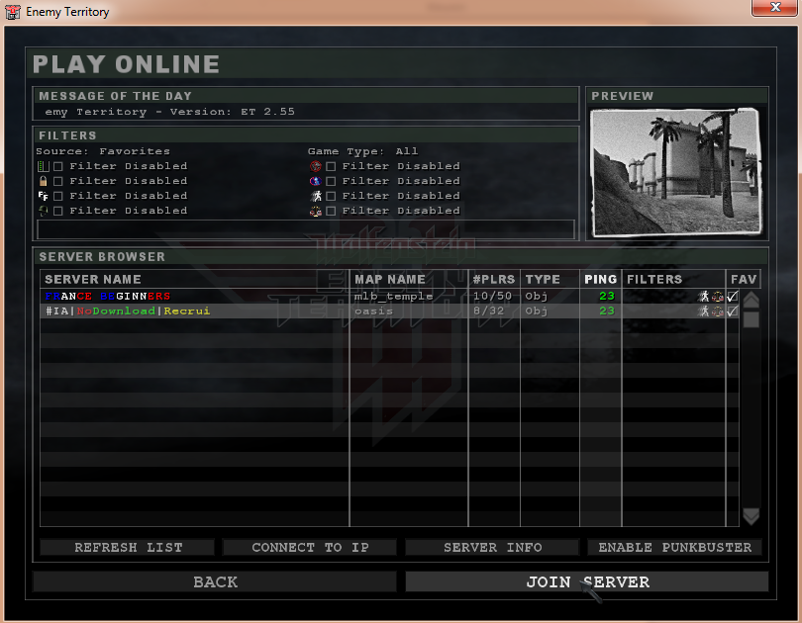

Now i click, JOIN SERVER

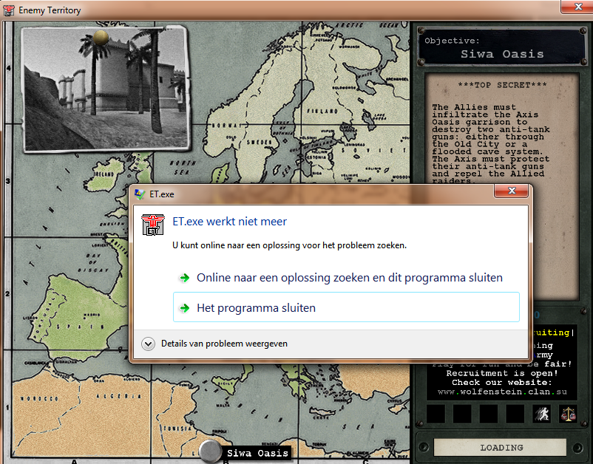

It crash when it’s loading. (Never had this before.)